Inequality Conditions

Definition
# Source: AI Source: Provided by: [Data Path: Persons Table -> ID Column: 1, Name_En Column: Motasem Essam] -> From: [ChatGPT] on [7/25/2026]
Inequality Conditions are geometric conditions that specify that one geometric quantity is greater than, less than, greater than or equal to, or less than or equal to another quantity.
They are used to compare:
- lengths
- distances
- angles
- areas
- perimeters
- radii
- side lengths
- diagonals
- coordinates
- geometric expressions
- positions of points and figures
Common inequality symbols are:
$$>, <, ≥, ≤$$
For example:
$$AB>CD$$
means segment $AB$is longer than segment $CD$.

Simple Definition
# Source: AI Source: Provided by: [Data Path: Persons Table -> ID Column: 1, Name_En Column: Motasem Essam] -> From: [ChatGPT] on [7/25/2026]
An Inequality Condition is a geometric requirement that says one quantity must be larger, smaller, or equal to another quantity.
Example:
$$AB<10$$
means that the length of $AB$must be less than $10$units.

Classification of Inequality Conditions
# Source: AI Source: Provided by: [Data Path: Persons Table -> ID Column: 1, Name_En Column: Motasem Essam] -> From: [ChatGPT] on [7/25/2026]
A practical classification is:
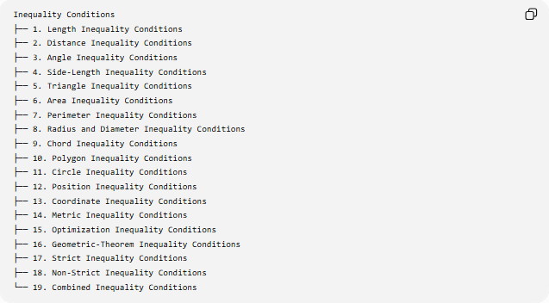
Inequality Conditions
├── 1. Length Inequality Conditions
├── 2. Distance Inequality Conditions
├── 3. Angle Inequality Conditions
├── 4. Side-Length Inequality Conditions
├── 5. Triangle Inequality Conditions
├── 6. Area Inequality Conditions
├── 7. Perimeter Inequality Conditions
├── 8. Radius and Diameter Inequality Conditions
├── 9. Chord Inequality Conditions
├── 10. Polygon Inequality Conditions
├── 11. Circle Inequality Conditions
├── 12. Position Inequality Conditions
├── 13. Coordinate Inequality Conditions
├── 14. Metric Inequality Conditions
├── 15. Optimization Inequality Conditions
├── 16. Geometric-Theorem Inequality Conditions
├── 17. Strict Inequality Conditions
├── 18. Non-Strict Inequality Conditions
└── 19. Combined Inequality Conditions

1. Length Inequality Conditions
# Source: AI Source: Provided by: [Data Path: Persons Table -> ID Column: 1, Name_En Column: Motasem Essam] -> From: [ChatGPT] on [7/25/2026]
Definition
A Length Inequality Condition compares the lengths of geometric segments or other measurable lengths.
Common forms
$$AB>CD \\ AB<CD \\ AB≥CD \\ AB≤CD$$
Example
Suppose:
$$AB=8, CD=5$$
Then:
$$\boxed{AB>CD}$$
because $8>5$.
Another example
A segment must have a length less than $12$:
$$\boxed{AB<12}$$
This condition allows any positive length below $12$.

2. Distance Inequality Conditions
# Source: AI Source: Provided by: [Data Path: Persons Table -> ID Column: 1, Name_En Column: Motasem Essam] -> From: [ChatGPT] on [7/25/2026]
Definition
A Distance Inequality Condition compares distances between points or between geometric objects.
Example
For a point $P$and center $O$:
$$OP<r$$
means $P$lies inside a circle of radius $r$.
Similarly:
$$OP>r$$
means $P$lies outside the circle.
Example
If:
$$OP=4, r=6$$
then:
$$OP<r$$
so $P$is inside the circle.
Important forms
$$OP<r→\text{inside} \\ OP=r→\text{on the circle} \\ OP>r→\text{outside}$$

3. Angle Inequality Conditions
# Source: AI Source: Provided by: [Data Path: Persons Table -> ID Column: 1, Name_En Column: Motasem Essam] -> From: [ChatGPT] on [7/25/2026]
Definition
An Angle Inequality Condition compares two or more angle measures.
Examples
$$∠A>∠B \\ ∠C<{90}^{∘} \\ ∠D≥{60}^{∘}$$
Example
If:
$$∠A={70}^{∘}, ∠B={40}^{∘}$$
then:
$$\boxed{∠A>∠B}$$
Triangle example
If:
$$A>B$$
then the side opposite $A$is longer than the side opposite $B$:
$$\boxed{a>b}$$
This is the side–angle inequality relationship.

4. Side-Length Inequality Conditions
# Source: AI Source: Provided by: [Data Path: Persons Table -> ID Column: 1, Name_En Column: Motasem Essam] -> From: [ChatGPT] on [7/25/2026]
Definition
A Side-Length Inequality Condition compares the lengths of sides of a polygon, especially a triangle.
Example
For triangle $ABC$:
$$AB<AC$$
means side $AB$is shorter than side $AC$.
Using standard notation:
$$c<b$$
because:
$$AB=c, AC=b.$$
Triangle relationship
The larger side of a triangle is opposite the larger angle.
Thus:
$$a>b ⟺ A>B$$
where $a$and $b$are opposite $A$and $B$.

5. Triangle Inequality Conditions
# Source: AI Source: Provided by: [Data Path: Persons Table -> ID Column: 1, Name_En Column: Motasem Essam] -> From: [ChatGPT] on [7/25/2026]
Definition
Triangle Inequality Conditions specify the necessary inequalities that three lengths must satisfy in order to form a non-degenerate triangle.
For sides $a,b,c$:
$$\boxed{a+b>c} \\ \boxed{a+c>b} \\ \boxed{b+c>a}$$
These can also be expressed as:
$$\boxed{∣a-b∣<c<a+b}$$
Example
Can $3,4,6$form a triangle?
Check:
$$3+4>6 \\ 7>6 \\ 3+6>4 \\ 9>4 \\ 4+6>3 \\ 10>3$$
Therefore:
$$\boxed{3,4,6\text{ can form a triangle}}$$
Counterexample
Lengths $2,3,6$cannot form a triangle because:
$$2+3<6 \\ 5<6$$
Therefore:
$$\boxed{\text{No triangle exists}}$$

6. Area Inequality Conditions
# Source: AI Source: Provided by: [Data Path: Persons Table -> ID Column: 1, Name_En Column: Motasem Essam] -> From: [ChatGPT] on [7/25/2026]
Definition
An Area Inequality Condition compares the areas of geometric regions or gives a bound on possible area.
Example
If two figures have:
$$A_{1}=30, A_{2}=45$$
then:
$$\boxed{A_{1}<A_{2}}$$
Fixed-perimeter example
Among rectangles with a fixed perimeter $P$:
$$\boxed{A≤\frac{P^{2}}{16}}$$
Equality occurs when the rectangle is a square.
For:
$$P=20$$
the maximum area is:
$$A≤\frac{{20}^{2}}{16}=25.$$
Thus:
$$\boxed{A≤25}$$

7. Perimeter Inequality Conditions
# Source: AI Source: Provided by: [Data Path: Persons Table -> ID Column: 1, Name_En Column: Motasem Essam] -> From: [ChatGPT] on [7/25/2026]
Definition
A Perimeter Inequality Condition compares perimeters or establishes bounds on the perimeter of a figure.
Example
$$P_{1}>P_{2}$$
means figure 1 has a greater perimeter than figure 2.
Isoperimetric inequality
For a plane figure with area $A$and perimeter $P$:
$$\boxed{4πA≤P^{2}}$$
or:
$$\boxed{P≥2\sqrt{πA}}$$
Equality occurs for a circle.
Example
If:
$$A=25π$$
then:
$$P≥2\sqrt{π\left(25π\right)} \\ P≥10π.$$

8. Radius and Diameter Inequality Conditions
# Source: AI Source: Provided by: [Data Path: Persons Table -> ID Column: 1, Name_En Column: Motasem Essam] -> From: [ChatGPT] on [7/25/2026]
Definition
These conditions compare radii or diameters of circles or spheres.
Examples
$$r_{1}>r_{2} \\ d_{1}≤d_{2}$$
Since:
$$d=2r,$$
we have:
$$r_{1}>r_{2} ⟺ d_{1}>d_{2}.$$
Example
If:
$$r_{1}=8, r_{2}=5$$
then:
$$\boxed{r_{1}>r_{2}}$$
and:
$$d_{1}=16>10=d_{2}.$$

9. Chord Inequality Conditions
# Source: AI Source: Provided by: [Data Path: Persons Table -> ID Column: 1, Name_En Column: Motasem Essam] -> From: [ChatGPT] on [7/25/2026]
Definition
A Chord Inequality Condition compares chord lengths or establishes bounds on the length of a chord.
For a circle of radius $R$, every chord satisfies:
$$\boxed{c≤2R}$$
because the diameter is the longest chord.
Example
If:
$$R=10$$
then every chord satisfies:
$$\boxed{c≤20}.$$
Equality:
$$c=20$$
occurs only when the chord is a diameter.

10. Polygon Inequality Conditions
# Source: AI Source: Provided by: [Data Path: Persons Table -> ID Column: 1, Name_En Column: Motasem Essam] -> From: [ChatGPT] on [7/25/2026]
Definition
Polygon Inequality Conditions compare measurable properties of polygons or provide bounds involving their sides, areas, angles, or perimeters.
Example: maximum area
For a regular $n$-gon with fixed perimeter $P$:
$$\boxed{A≤\frac{P^{2}}{4n}\cot\left(\frac{π}{n}\right)}$$
Equality occurs for the regular $n$-gon.
Example
For a quadrilateral with fixed perimeter, the square gives the maximum area among rectangles.

11. Circle Inequality Conditions
# Source: AI Source: Provided by: [Data Path: Persons Table -> ID Column: 1, Name_En Column: Motasem Essam] -> From: [ChatGPT] on [7/25/2026]
Definition
Circle Inequality Conditions describe inequalities involving circles, their radii, chords, distances, tangents, or relative positions.
Point relative to circle
For center $O$and radius $r$:
$$OP<r$$
→ $P$is inside.
$$OP=r$$
→ $P$is on the circle.
$$OP>r$$
→ $P$is outside.
Circle-circle position
For circles with radii $r_{1},r_{2}$and center distance $d$:
$$d>r_{1}+r_{2}$$
→ separate circles.
$$d=r_{1}+r_{2}$$
→ externally tangent.
$$∣r_{1}-r_{2}∣<d<r_{1}+r_{2}$$
→ two intersections.
$$d=∣r_{1}-r_{2}∣$$
→ internally tangent.
$$d<∣r_{1}-r_{2}∣$$
→ one circle lies inside the other without intersection.

12. Position Inequality Conditions
# Source: AI Source: Provided by: [Data Path: Persons Table -> ID Column: 1, Name_En Column: Motasem Essam] -> From: [ChatGPT] on [7/25/2026]
Definition
A Position Inequality Condition uses inequalities to specify where a point or figure is located relative to another geometric object or region.
Example
$$x>0$$
specifies the right half-plane.
$$y<0$$
specifies the lower half-plane.
Circle example
$${\left(x-h\right)}^{2}+{\left(y-k\right)}^{2}<r^{2}$$
represents the interior of a circle.
The boundary is:
$${\left(x-h\right)}^{2}+{\left(y-k\right)}^{2}=r^{2}.$$
The exterior is:
$${\left(x-h\right)}^{2}+{\left(y-k\right)}^{2}>r^{2}.$$

13. Coordinate Inequality Conditions
# Source: AI Source: Provided by: [Data Path: Persons Table -> ID Column: 1, Name_En Column: Motasem Essam] -> From: [ChatGPT] on [7/25/2026]
Definition
A Coordinate Inequality Condition describes a geometric region using inequalities involving coordinates.
Examples
$$x≥0$$
represents the right half-plane including the $y$-axis.
$$y<3$$
represents the region below the line $y=3$.
Example: circular region
$$x^{2}+y^{2}≤25$$
represents the disk centered at the origin with radius $5$.
Notice:
$$x^{2}+y^{2}=25$$
represents only the circle boundary, while:
$$x^{2}+y^{2}≤25$$
includes the interior.

14. Metric Inequality Conditions
# Source: AI Source: Provided by: [Data Path: Persons Table -> ID Column: 1, Name_En Column: Motasem Essam] -> From: [ChatGPT] on [7/25/2026]
Definition
A Metric Inequality Condition compares measurable geometric quantities such as lengths, distances, areas, or radii.
Examples include:
$$AB+BC≥AC$$
and:
$$R≥2r.$$
Euler's inequality
For every triangle:
$$\boxed{R≥2r}$$
where:
- $R$= circumradius
- $r$= inradius
Equality occurs for an equilateral triangle.
Weitzenböck's inequality
For a triangle with area $K$:
$$\boxed{a^{2}+b^{2}+c^{2}≥4\sqrt{3}K}$$
Equality occurs for an equilateral triangle.

15. Optimization Inequality Conditions
# Source: AI Source: Provided by: [Data Path: Persons Table -> ID Column: 1, Name_En Column: Motasem Essam] -> From: [ChatGPT] on [7/25/2026]
Definition
An Optimization Inequality Condition establishes a maximum or minimum possible value of a geometric quantity.
Typical forms are:
$$A≤A_{max}$$
or:
$$P≥P_{min}.$$
Example
Among all rectangles with a fixed perimeter, the square has maximum area.
Thus:
$$\boxed{A≤\frac{P^{2}}{16}}$$
with equality for a square.
Another example
Among all plane figures with a fixed perimeter, the circle has the greatest area:
$$\boxed{A≤\frac{P^{2}}{4π}}.$$

16. Geometric-Theorem Inequality Conditions
# Source: AI Source: Provided by: [Data Path: Persons Table -> ID Column: 1, Name_En Column: Motasem Essam] -> From: [ChatGPT] on [7/25/2026]
Many important geometric theorems and inequalities provide conditions of the form:
$$\boxed{\text{Geometric Quantity}≥\text{Bound}}$$
or:
$$\boxed{\text{Geometric Quantity}≤\text{Bound}}.$$
Examples:
Triangle Inequality
$$a+b>c.$$
Euler's Inequality
$$R≥2r.$$
Weitzenböck's Inequality
$$a^{2}+b^{2}+c^{2}≥4\sqrt{3}K.$$
Isoperimetric Inequality
$$4πA≤P^{2}.$$
Erdős–Mordell Inequality
For an interior point $P$of triangle $ABC$:
$$\boxed{PA+PB+PC≥2\left(d_{a}+d_{b}+d_{c}\right)}$$
where $d_{a},d_{b},d_{c}$are the perpendicular distances from $P$to the three sides.

17. Strict Inequality Conditions
# Source: AI Source: Provided by: [Data Path: Persons Table -> ID Column: 1, Name_En Column: Motasem Essam] -> From: [ChatGPT] on [7/25/2026]
Definition
A Strict Inequality Condition requires one quantity to be strictly greater or strictly less than another.
Symbols:
$$>$$
and:
$$<$$
Examples
$$AB>CD \\ ∠A<{90}^{∘} \\ OP<r$$
Important property
Equality is not allowed.
For example:
$$x<5$$
does not include $x=5$.

18. Non-Strict Inequality Conditions
# Source: AI Source: Provided by: [Data Path: Persons Table -> ID Column: 1, Name_En Column: Motasem Essam] -> From: [ChatGPT] on [7/25/2026]
Definition
A Non-Strict Inequality Condition allows equality as well as greater-than or less-than values.
Symbols:
$$≥, ≤$$
Examples
$$AB≥CD \\ A≤25 \\ OP≤r.$$
For example:
$$OP≤r$$
describes the entire closed disk, including its boundary.

19. Combined Inequality Conditions
# Source: AI Source: Provided by: [Data Path: Persons Table -> ID Column: 1, Name_En Column: Motasem Essam] -> From: [ChatGPT] on [7/25/2026]
Definition
A Combined Inequality Condition uses two or more inequalities simultaneously.
Example
A point is required to satisfy:
$$x>0$$
and:
$$y>0.$$
Together:
$$\boxed{x>0∧y>0}$$
This specifies the first quadrant.
Example with a circle
Suppose:
$$x^{2}+y^{2}≤25$$
and:
$$y≥0.$$
The result is the upper semicircular region.
Conceptually:
$$\boxed{\text{Circle Region}∩\text{Half-Plane}}$$

Inequality Conditions and Loci
# Source: AI Source: Provided by: [Data Path: Persons Table -> ID Column: 1, Name_En Column: Motasem Essam] -> From: [ChatGPT] on [7/25/2026]
An equality often produces a boundary locus, while an inequality usually produces a region.
For example:
$$OP=r$$
produces a circle.
But:
$$OP<r$$
produces the interior of the circle.
And:
$$OP≤r$$
produces the entire closed disk.
Therefore:
$$\boxed{\text{Equality Condition}→\text{Boundary Locus}}$$
while often:
$$\boxed{\text{Inequality Condition}→\text{Region}}$$
Example:
$${\left(x-h\right)}^{2}+{\left(y-k\right)}^{2}=r^{2}$$
→ circle
$${\left(x-h\right)}^{2}+{\left(y-k\right)}^{2}<r^{2}$$
→ interior
$${\left(x-h\right)}^{2}+{\left(y-k\right)}^{2}≤r^{2}$$
→ closed disk.

Inequality Conditions and Triangle Geometry
# Source: AI Source: Provided by: [Data Path: Persons Table -> ID Column: 1, Name_En Column: Motasem Essam] -> From: [ChatGPT] on [7/25/2026]
Inequalities are especially important in triangles.
Side inequality
$$a+b>c.$$
Side-angle comparison
$$a>b ⟺ A>B.$$
Acute triangle
For the largest side $c$:
$$c^{2}<a^{2}+b^{2}.$$
Right triangle
$$c^{2}=a^{2}+b^{2}.$$
Obtuse triangle
$$c^{2}>a^{2}+b^{2}.$$
Thus:
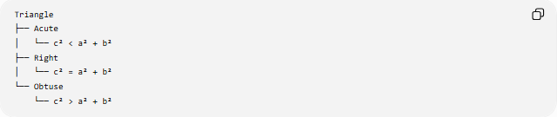
Triangle
├── Acute
│ └── c² < a² + b²
├── Right
│ └── c² = a² + b²
└── Obtuse
└── c² > a² + b²

Inequality Conditions and Perpendicular Geometry
# Source: AI Source: Provided by: [Data Path: Persons Table -> ID Column: 1, Name_En Column: Motasem Essam] -> From: [ChatGPT] on [7/25/2026]
A fundamental inequality is:
$$\boxed{PH≤PQ}$$
where:
- $P$is a point,
- $H$is the foot of the perpendicular from $P$to line $l$,
- $Q$is any other point on $l$.
Therefore:
The perpendicular segment from a point to a line is the shortest distance from the point to that line.
Equality occurs only when:
$$Q=H.$$

Inequality Conditions and Geometric Optimization
# Source: AI Source: Provided by: [Data Path: Persons Table -> ID Column: 1, Name_En Column: Motasem Essam] -> From: [ChatGPT] on [7/25/2026]
Inequalities are often used to answer questions such as:
- What is the largest possible area?
- What is the smallest possible perimeter?
- What is the shortest distance?
- What is the largest chord?
- What is the minimum length?
- Which figure maximizes an area under a constraint?
A typical optimization structure is:
$$\boxed{\text{Constraint}→\text{Inequality}→\text{Bound}→\text{Equality Case}}$$
Example:
$$P=\text{fixed} \\ A≤\frac{P^{2}}{16}$$
Equality:
$$\boxed{\text{Square}}$$

Important Equality Cases
# Source: AI Source: Provided by: [Data Path: Persons Table -> ID Column: 1, Name_En Column: Motasem Essam] -> From: [ChatGPT] on [7/25/2026]
An inequality becomes especially useful when we know when equality occurs.
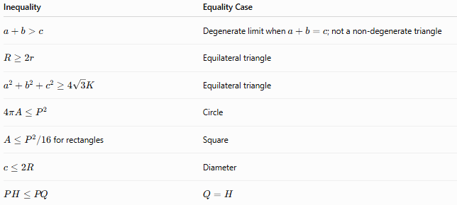
Inequality | Equality Case
$$a+b>c$$ | Degenerate limit when $a+b=c$; not a non-degenerate triangle
$$R≥2r$$ | Equilateral triangle
$$a^{2}+b^{2}+c^{2}≥4\sqrt{3}K$$ | Equilateral triangle
$$4πA≤P^{2}$$ | Circle
$A≤P^{2}/16$for rectangles | Square
$$c≤2R$$ | Diameter
$$PH≤PQ$$ | $$Q=H$$
The equality case often identifies the optimal or most symmetric configuration.

Coordinate Representation
# Source: AI Source: Provided by: [Data Path: Persons Table -> ID Column: 1, Name_En Column: Motasem Essam] -> From: [ChatGPT] on [7/25/2026]
Many inequality conditions can be expressed algebraically.
Distance
For:
$$A=\left(x_{1} , y_{1}\right), B=\left(x_{2} , y_{2}\right)$$
the distance is:
$$AB=\sqrt{{\left(x_{2}-x_{1}\right)}^{2}+{\left(y_{2}-y_{1}\right)}^{2}}.$$
A condition such as:
$$AB<10$$
becomes:
$$\boxed{\sqrt{{\left(x_{2}-x_{1}\right)}^{2}+{\left(y_{2}-y_{1}\right)}^{2}}<10}$$
Squared form
Because distances are nonnegative:
$$AB<10$$
is equivalent to:
$$\boxed{{\left(x_{2}-x_{1}\right)}^{2}+{\left(y_{2}-y_{1}\right)}^{2}<100}$$

Logical Structure of Inequality Conditions
# Source: AI Source: Provided by: [Data Path: Persons Table -> ID Column: 1, Name_En Column: Motasem Essam] -> From: [ChatGPT] on [7/25/2026]
Inequality conditions can be combined logically.
AND
$$C_{1}∧C_{2}$$
means both conditions must hold.
Geometrically:
$$\boxed{R=C_{1}∩C_{2}}$$
OR
$$C_{1}∨C_{2}$$
means at least one condition must hold.
Geometrically:
$$\boxed{R=C_{1}∪C_{2}}$$
Example
$$x≥0∧y≥0$$
gives the first quadrant including its boundary.

Key Formulas
# Source: AI Source: Provided by: [Data Path: Persons Table -> ID Column: 1, Name_En Column: Motasem Essam] -> From: [ChatGPT] on [7/25/2026]
Triangle Inequality
$$\boxed{a+b>c}$$
and cyclically.
Reverse Triangle Inequality
$$\boxed{∣a-b∣≤c}$$
for appropriate triangle-side/distance contexts.
Side–Angle Inequality
$$\boxed{a>b ⟺ A>B}$$
Pythagorean comparison
$$\boxed{\left\{\begin{matrix}c^{2}<a^{2}+b^{2} & \text{acute} \\ c^{2}=a^{2}+b^{2} & \text{right} \\ c^{2}>a^{2}+b^{2} & \text{obtuse}\end{matrix}\right.}$$
Euler's Inequality
$$\boxed{R≥2r}$$
Weitzenböck's Inequality
$$\boxed{a^{2}+b^{2}+c^{2}≥4\sqrt{3}K}$$
Isoperimetric Inequality
$$\boxed{4πA≤P^{2}}$$
Rectangle fixed-perimeter inequality
$$\boxed{A≤\frac{P^{2}}{16}}$$
Maximum chord
$$\boxed{c≤2R}$$
Point-to-line shortest distance
$$\boxed{PH≤PQ}$$
Circle interior
$$\boxed{{\left(x-h\right)}^{2}+{\left(y-k\right)}^{2}<r^{2}}$$
Closed disk
$$\boxed{{\left(x-h\right)}^{2}+{\left(y-k\right)}^{2}≤r^{2}}$$

Inequality Conditions vs Equality Conditions
# Source: AI Source: Provided by: [Data Path: Persons Table -> ID Column: 1, Name_En Column: Motasem Essam] -> From: [ChatGPT] on [7/25/2026]
These two condition types are closely related but different.
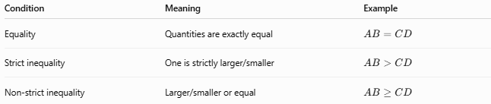
Condition | Meaning | Example
Equality | Quantities are exactly equal | $$AB=CD$$
Strict inequality | One is strictly larger/smaller | $$AB>CD$$
Non-strict inequality | Larger/smaller or equal | $$AB≥CD$$
For example:
$$OP=r$$
describes a circle boundary.
But:
$$OP<r$$
describes its interior.
And:
$$OP≤r$$
describes the closed circular region.

Classification Summary
# Source: AI Source: Provided by: [Data Path: Persons Table -> ID Column: 1, Name_En Column: Motasem Essam] -> From: [ChatGPT] on [7/25/2026]
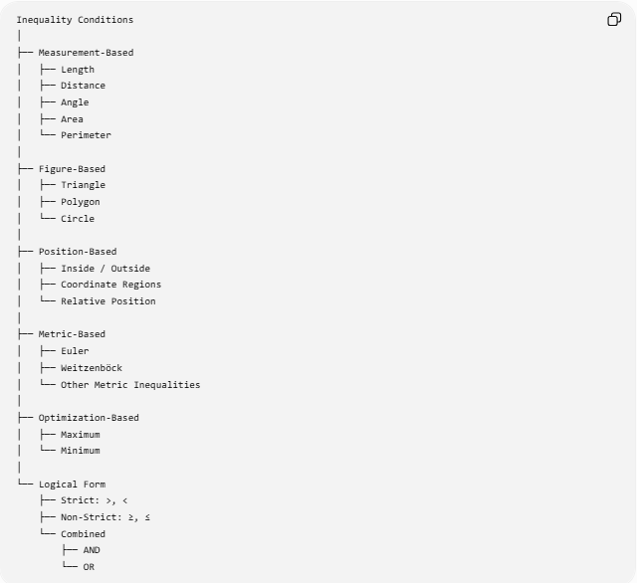
Inequality Conditions
│
├── Measurement-Based
│ ├── Length
│ ├── Distance
│ ├── Angle
│ ├── Area
│ └── Perimeter
│
├── Figure-Based
│ ├── Triangle
│ ├── Polygon
│ └── Circle
│
├── Position-Based
│ ├── Inside / Outside
│ ├── Coordinate Regions
│ └── Relative Position
│
├── Metric-Based
│ ├── Euler
│ ├── Weitzenböck
│ └── Other Metric Inequalities
│
├── Optimization-Based
│ ├── Maximum
│ └── Minimum
│
└── Logical Form
├── Strict: >, <
├── Non-Strict: ≥, ≤
└── Combined
├── AND
└── OR

Key Points
# Source: AI Source: Provided by: [Data Path: Persons Table -> ID Column: 1, Name_En Column: Motasem Essam] -> From: [ChatGPT] on [7/25/2026]
- Inequality Conditions compare geometric quantities rather than requiring exact equality.
- The four fundamental symbols are:
$$>, <, ≥, ≤$$
- Inequalities can involve:
$$\text{lengths, distances, angles, areas, perimeters, radii, coordinates, and positions}.$$
- The Triangle Inequality determines whether three lengths can form a non-degenerate triangle.
- Side–angle inequalities connect side lengths with opposite angle sizes.
- Many geometric inequalities establish maximum or minimum values.
- Equality cases are important because they often identify special figures such as:
$$\text{equilateral triangle}, \text{square}, \text{circle}.$$
- An equality condition often defines a boundary, whereas an inequality defines a region.
- Multiple inequality conditions can be combined using logical operations such as AND and OR.
- Inequality conditions are fundamental in geometry proofs, loci, optimization, coordinate geometry, and geometric analysis.

Conclusion
# Source: AI Source: Provided by: [Data Path: Persons Table -> ID Column: 1, Name_En Column: Motasem Essam] -> From: [ChatGPT] on [7/25/2026]
Inequality Conditions are geometric requirements that compare quantities or restrict their possible values using $>,<,≥,≤$. They provide a way to describe relative size, position, feasibility, bounds, and optimal configurations.
A useful conceptual relationship is:
$$\boxed{\text{Geometric Condition}→\text{Inequality}→\text{Allowed Region or Bound}→\text{Equality Case / Extremum}}$$
They are therefore an essential part of geometry, connecting measurement, comparison, loci, coordinate regions, triangle geometry, classical inequalities, optimization, and geometric proofs.

